Analysis Report

South Metropolitan TAFE | RAD

Carl Haricombe

Sprint 1

2020

Table of Contents

Business Rules in Software Development 1

Managed Services Quality Assurance 2

Quality Assurance: 2

Software Verification: 2

Software Validity: 2

Client Requirements 3

Project Plan 4

Notes: 5

Meeting 5

Analysis Documentation 5

Multi-platform 6

Backend Code 6

Test Documentation 7

Master Documentation 7

Presentation 8

# Business Rules in Software Development

The business rule in software development refers to separating the coding end of the application into a logical stream where each person in the team is then assigned to an area in that stream. This will often come into effect when the client has a change of mind in what they want the application to do or look like.

Being given the RAD Agile methodology we had to follow the 6 steps to designing and developing the final prototype and having run through the Quality Assurance we decided as a team it would be best to undergo a grey box testing validation where Calvin Moylan handled the backend code to develop what the client required. Then Panashe Madakasi had to do the testing of the front to ensure that Calvin Moylan’s followed the requirements and met all the specifications to it (Panashe did have an understanding of the backend but when doing the testing was only required to test the front end which was able to tell us that the backend code Calvin Moylan’s used is working correctly). For validation we made use of dynamic validating method where we are able to monitor the working behavior of the software while executing the prototype.

In saying as Scrum master I was given the responsibility of dividing the team accordingly;

Carl Haricombe

1. Will be creating a project management plan that organizes everyone’s roles in a format that does not clash with one another but instead flows from one stage to the next.
2. I was also given the task to type up the analysis report where I underline everyone’s roles.
3. Finally I was given the task of designing the Master Document and add the necessary data of the first sprint to it.

Calvin Moylan

1. He was asked to make the necessary adjustments to the backend to ensure the Movie database website would be multi-platform.
2. He was in charge of creating a source control site for the team in which we could upload our completed or updated information where we would be able to double check one another’s work to keep a form of accuracy before bringing it forth to the client
3. He finally had to write the multiplatform report

Panashe Madakasi

1. Was in charge of developing the test documentation according to the QA standards of the Cite whilst ensuring that Calvin met the client’s requirements.

# Managed Services Quality Assurance

## Quality Assurance:

This is to ensure the quality set throughout a set of activities. It is used to both verify and validate the product, by verification it evaluates the documents, code and plans and requirements while validating it evaluates the product as a whole which is done through testing of every aspect that make the product.

In order to do the above the team has to abide by the quality standards example ISO 9001 and 90003.

### Software Verification:

This refers to checking and verifying the data and information in order to confirm credibility as well as the accuracy of the project. In this case we are checking the development stages and ensuring that we are following the requirements of the client.

There are normally 2 types of verifications

#### Static verification

This is where we inspect the code before execution, ensuring the requirements and specs are being met.

#### Dynamic verification

This focuses on the working behavior of the software and is done during the execution of the system.

### Software Validity:

This is when an actual test is performed on the project. This form of assurance ensures validating the critical aspects of the product. This is one of the most important aspects of the SDLC which in the end helps the team create the project at its peak performance.

There are 3 types of validation testing namely;

#### Black Box testing

This is where the internal design of the prototype that is being tested, isn’t directly known to the tester.

#### White Box testing

This method allows the tester to have complete transparency with the prototype.

#### Grey Box testing

This is more of a form of debugging; this testing is where the tester has a partial understanding of the design behind the prototype. Allowing the front-end testing to verify how the backend is working and running as expected.

# Client Requirements

The client had been given a test prototype of what they had first asked for however, they had then gone back and discussed that they wanted a Multi-platform website which had to be one of 2 types;

* Responsive
* Adaptive

Meaning that the website should be user friendly on different forms of devices like mobile devices, tablets as well as computer monitors.

There is an In-depth explanation on which of the 2 website formats we used and why. This was written up by Calvin Moylan as well as a well written up test document proving that we had met all the new requirements, this document was written up by Panashe Medakasi.

# Project Plan

Below is the project management plan which is where the Scrum Master of this week had divided everyone into doing their duties and what days they are expected to be worked on and completed so that tasks do not overlap one another. This was necessary to ensure we stick to due dates, in this case Sprint 1 had to be completed by the 11 of November 2020 because the 12 of November 2020 was the due date for the first presentation with the client to demonstrate our progress and that we had managed to complete and display what ACME Entertainment Ltd had required us to do.

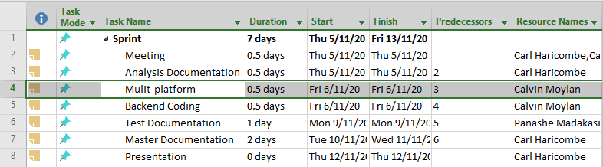

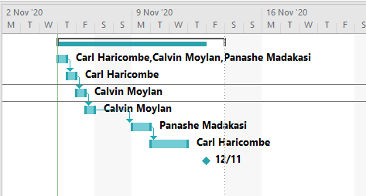

## Notes:

### Meeting

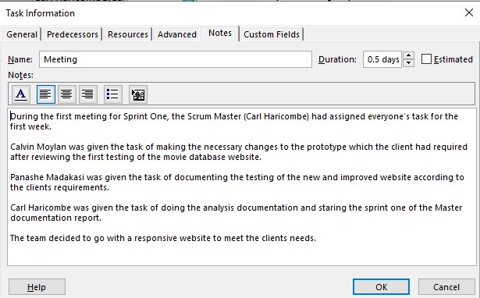

### Analysis Documentation

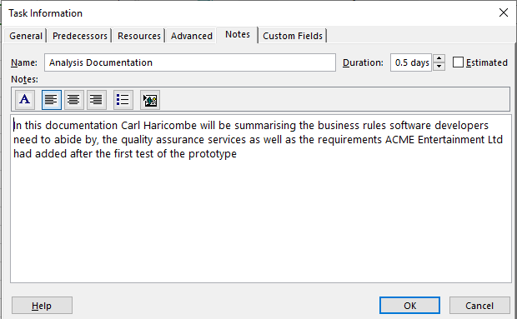

### Multi-platform

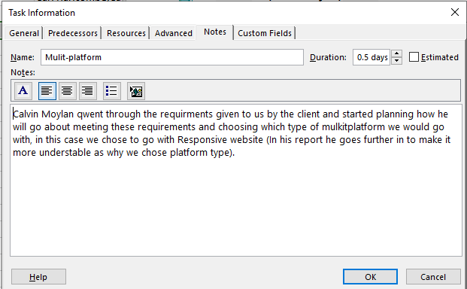

### Backend Code

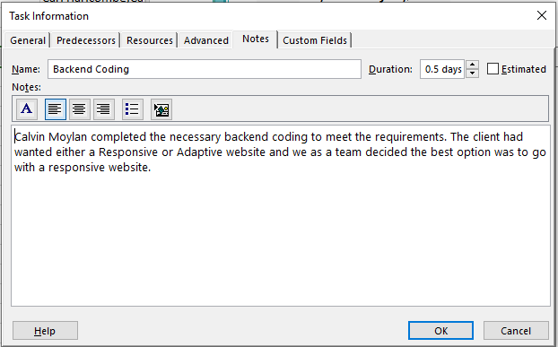

### Test Documentation

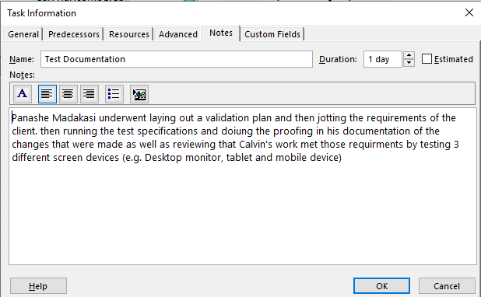

### Master Documentation

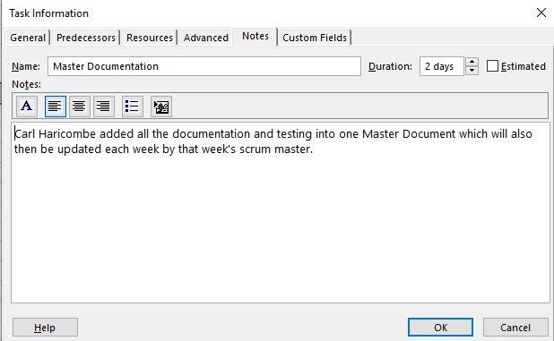

### Presentation

